Inputs & Outputs:

* Home page:
* Register/Login
  + Login page if the user have previously registered with the system.

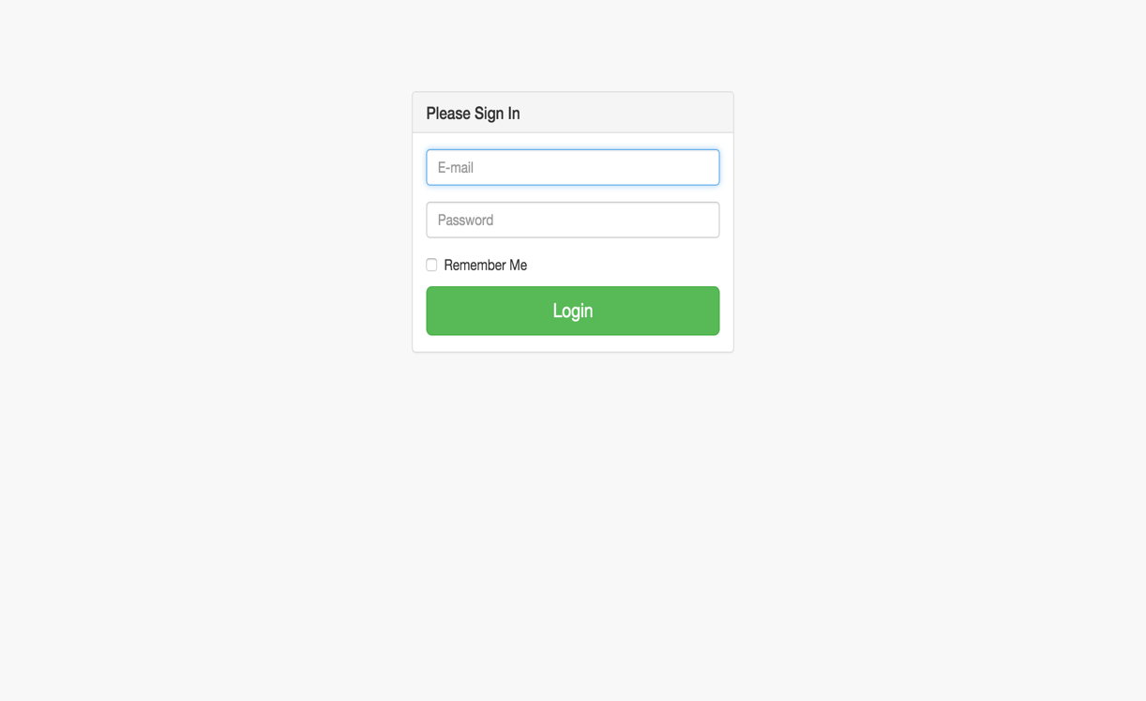

* Register page:
  + If the user has never registered with

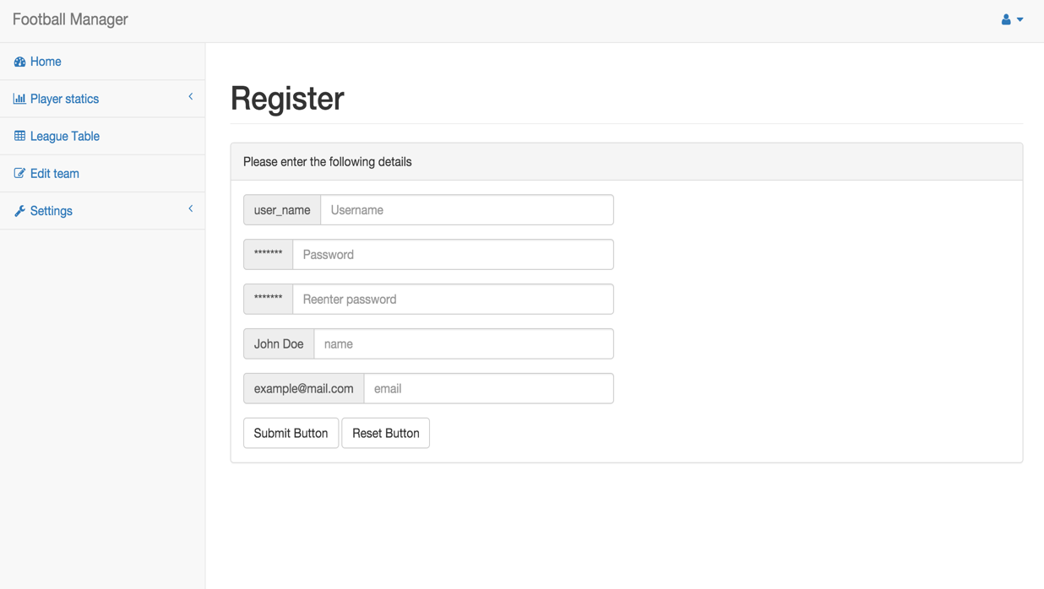

* When logged in or registered, here are the pages that are available
  + League Table(Where the ranking of each team’s performance throughout the competition)